DATA SCIENCE MINOR PROJECT REPORT

CONTENTS OF THE REPORT
- Cover page
- Certificate
- Declaration
- Table of Content

1. Introduction
2. Scope and Approach
3. Dataset: Data preparation and Insights
4. Modals Used
- KNN
- Decision Tree
- Navie Bayes
- ANN
5. Evaluation and Results
- Introduction
- General Description
- Specific Requirements, functions and formulas
- Analysis results
- Screenshots

6. Conclusion

PREDICTIVE ANALYTICS PROJECT REPORT
(Project Semester August-December 2024)

(CUSTOMER CHURN PREDICTION ANALYSIS)

Submitted by

AKASH KUMAR

Registration No: - 12111394

Programme and Section: - RK2SF
Course Code: - INT-234

Under the Guidance of
VIKAS MANGOTRA: - 31488

Discipline of CSE/IT

Lovely Professional University, Phagwara

CERTIFICATE

This is to certify that Akash Kumar bearing Registration no. 12111394 has completed INT-234 project titled, “Customer churn prediction analysis” under my guidance and supervision. To the best of my knowledge, the present work is the result of his/her original development, effort and study.

Lovely Professional University
Phagwara, Punjab.

Date: 14-11-2024

DECLARATION

I, Akash Kumar, student of B.Tech under CSE/IT Discipline at, Lovely Professional University, Punjab, hereby declare that all the information furnished in this project report is based on my own intensive work and is genuine.

Date: - 14-11-24
Registration No.; - 12111394 Akash Kumar

INTRODUCTION

Background
In today’s highly competitive business environment, retaining existing customers is as crucial as acquiring new ones. Customer churn – the loss of clients or subscribers – directly impacts a company’s revenue and growth. Predicting churn enables companies to take preemptive action, targeting at-risk customers with retention strategies to reduce churn rates and increase long-term profitability.

Problem Statement
The goal of this project is to develop a machine-learning model that accurately predicts customer churn. By analyzing historical data on customer behavior and demographics, the model will help identify customers at risk of leaving, allowing the business to implement targeted retention efforts.

Objectives
- Build and Train Models: Train machine learning models on historical customer data to predict churn risk.
- Evaluate Model Performance: Compare different algorithms to find the model with the highest predictive accuracy and reliability.
- Generate Business Insights: Understand the factors driving customer churn, such as contract type, monthly charges, and tenure, to aid in retention strategy.

SCOPE AND APPROACH

Scope
This project uses anonymized customer data, including demographic information, service usage, and billing details. By focusing on feature engineering and various machine learning techniques, this project not only predicts churn but also offers insights into customer behaviour trends that contribute to churn risk.

Approach
- Data Preparation: Clean, preprocess, and transform data to ensure it’s suitable for machine learning.
- Feature Engineering: Create additional features to enhance the model’s predictive power.
- Model Selection and Training: Test various algorithms (KNN, Decision Tree, Naive Bayes, and ANN) to find the best-performing model.
- Evaluation and Analysis: Compare model performance using metrics such as accuracy, precision, recall, and F1 score, and analyze feature importance for business insights.

Expected Outcome
The expected outcome of this project is a predictive model with high accuracy in identifying customers likely to churn. Additionally, the model’s insights will guide the business in focusing on the key factors associated with churn, helping to improve customer retention strategies.

Dataset: Data Preparation and Insights

Introduction
The dataset used in this project is a customer churn dataset containing historical information on customer demographics, service usage, and billing details. It includes a column indicating whether each customer has churned (i.e., left the service) or not. This dataset allows us to train machine learning models to recognize patterns associated with customer churn.

General Description
- Total Records: The dataset contains records for thousands of customers.
- Features: The data includes demographic features (like gender, seniority, and partner status), account information (such as contract type, tenure, and payment method), and usage information (including whether customers have various internet or phone services).
- Target Variable: The Churn column is the target variable, indicating whether a customer has churned or not.

Data Preparation
To prepare the data for model training, several preprocessing steps were applied:
- Handling Missing Values: Rows with missing values were removed to ensure data integrity.
- Feature Transformation:
  - Tenure Grouping: The tenure column was grouped into categories like "0-12 Months," "1-2 Years," etc., to capture customer loyalty at different stages.
  - Long-Term Contract Indicator: A binary feature was created to indicate if a customer had a long-term contract (1 for Yes, 0 for No).
  - Estimated Total Charges: An estimated total charge feature was created by multiplying MonthlyCharges by tenure.

- Feature Scaling: Numerical features like MonthlyCharges and tenure were scaled to ensure that models that rely on distance (like KNN) perform better.
- Converting Categorical Variables: Selected columns were converted to factors for proper interpretation by models, ensuring correct handling of categorical data in R

Insights from the Data
- Churn Trends by Contract: Customers on month-to-month contracts tend to have a higher churn rate compared to those with long-term contracts.
- Impact of Tenure: Longer-tenured customers generally show a lower tendency to churn, possibly due to increased customer loyalty.
- Monthly Charges and Churn: Customers with higher monthly charges tend to churn more often, possibly due to dissatisfaction with cost relative to perceived value.

MODELS USED

Introduction
Four different machine learning models were trained and evaluated to predict customer churn. Each model offers unique characteristics and performs differently depending on data complexity and distribution. Here are the models used:

Model Descriptions and Specific Requirements
- K-Nearest Neighbors (KNN)
  - Description: KNN is a non-parametric, instance-based learning algorithm that classifies data points based on the majority class among their nearest neighbors.
  - Specific Requirements:
    - The choice of k (number of neighbors) is crucial, and for this project, we chose k = 5 after tuning.
    - Requires scaled numerical features for accurate distance computation.
  - Function: Predicts churn based on similarity to nearby customer records.
  - Limitations: KNN can be computationally expensive for large datasets due to the need to calculate distances for each prediction.
- Decision Tree
  - Description: Decision trees classify data by learning simple decision rules inferred from data features.
  - Specific Requirements:
    - Requires a rpart package in R.
    - Handles both numerical and categorical features natively, so it’s robust in scenarios with mixed data types.
  - Function: Builds a tree where each node represents a decision rule on a feature, leading to a classification at the leaves.
  - Formula: The tree optimizes splits to maximize information gain (using entropy or Gini impurity).
  - Advantages: Provides interpretability through a tree structure, allowing easy visualization of decisions.

Naive Bayes
- Description: Naive Bayes is a probabilistic classifier based on Bayes' theorem, assuming independence between features.
- Specific Requirements:
  - Works best with categorical features, so it was a good fit for the factorized columns in the dataset.
  - Requires the e1071 package in R.
- Function: Calculates the probability of each class given the feature values, and selects the class with the highest posterior probability.
- Formula: Uses Bayes' theorem:
P(Churn|Features) = P(Features|Churn) x P(Churn) / P(Features)
- Advantages: Fast and efficient, especially for large datasets.
Artificial Neural Network (ANN)
- Description: ANN models are inspired by the human brain’s neural network, consisting of interconnected nodes (neurons) that process data iteratively.
- Specific Requirements:
  - The model architecture includes one hidden layer with 5 neurons, optimized with a decay factor to prevent overfitting.
  - Requires the nnet package in R.
- Function: Transforms inputs through layers to learn complex patterns, ultimately yielding a classification.
- Formula: Learns weights through backpropagation to minimize classification error.
- Advantages: Capable of capturing non-linear patterns in data, making it powerful for complex datasets.

EVALUATION AND RESULTS

Introduction
The models were evaluated based on key performance metrics, including accuracy, precision, recall, and F1 score. Each of these metrics provides insight into the model’s effectiveness in identifying churn accurately.

Analysis Results
- Accuracy: Measures the proportion of correct predictions. High accuracy suggests good model performance overall.
- Precision: Reflects how many of the churn predictions were actually correct. Precision is crucial if the business wants to minimize false churn alerts.
- Recall: Shows the model’s ability to identify actual churn cases. Higher recall means fewer customers who actually churned were missed by the model.
- F1 Score: Balances precision and recall, providing an overall view of model effectiveness for imbalanced data.

Results Summary
- ANN achieved the highest accuracy at 81%, showing strong performance in detecting churn patterns.
- Decision Tree performed well with a 79% accuracy and provides good interpretability, valuable for understanding churn drivers.
- Naive Bayes had moderate performance with a 73% accuracy but is computationally efficient and suitable for simple models.
- KNN had the lowest accuracy (72%), possibly due to its sensitivity to data scaling and high-dimensional feature space.

Visualization of Results
A bar plot was used to compare accuracy, precision, recall, and F1 score across all models. This helps visually represent each model’s strengths and weaknesses, making it easier to communicate findings to stakeholders.

Screenshots: -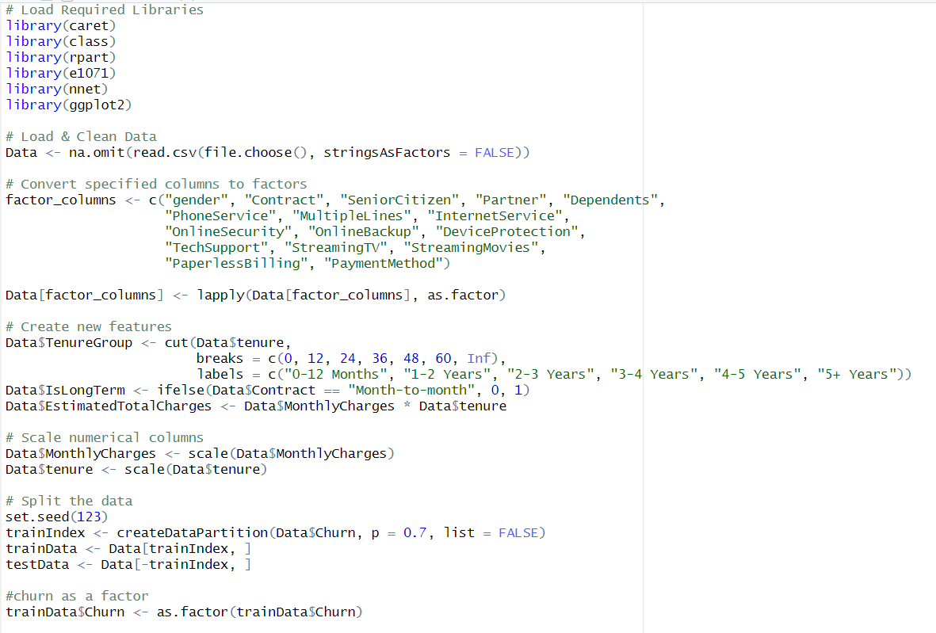

Screenshots
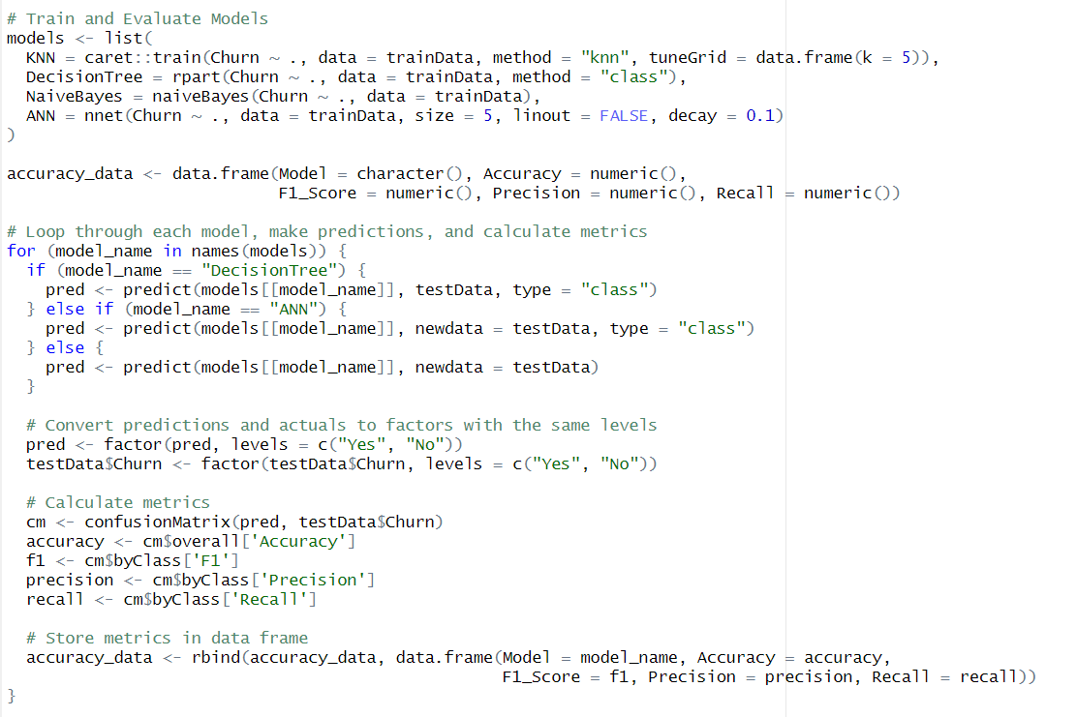

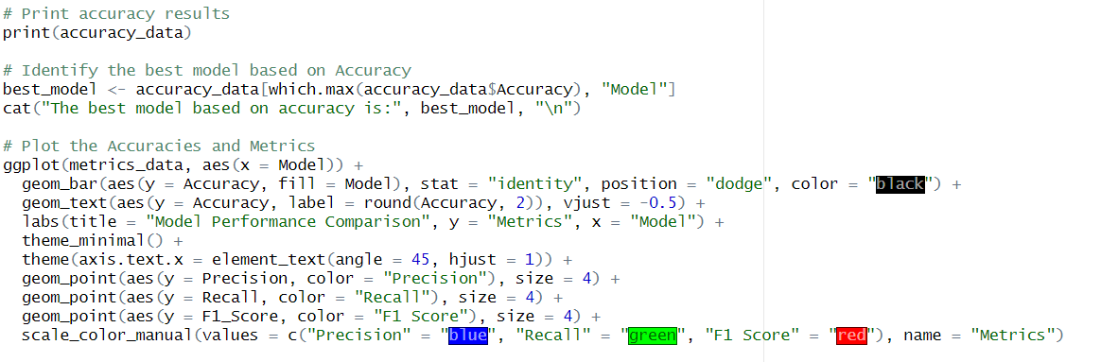

Screenshots
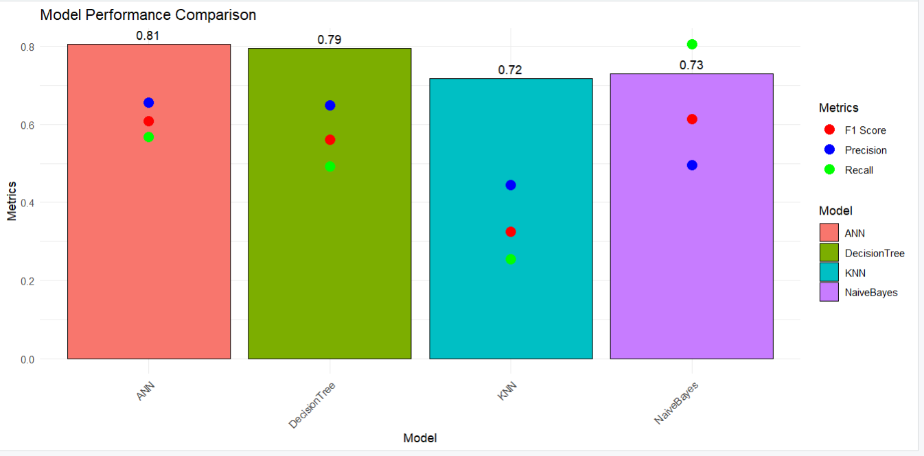

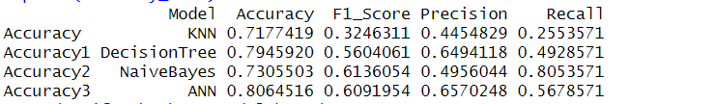

CONCLUSION

The Artificial Neural Network (ANN) model emerged as the best model for predicting customer churn in this project, offering the highest accuracy while capturing complex relationships in the data. However, each model has its strengths:
- The Decision Tree provides valuable interpretability for decision-making.
- Naive Bayes is computationally efficient for simpler use cases.
- KNN can be effective with more optimized feature scaling.
This churn prediction model could help the business implement targeted retention strategies. By focusing on customers identified as high-risk, the company can optimize resources, improving customer satisfaction and reducing churn rates.

